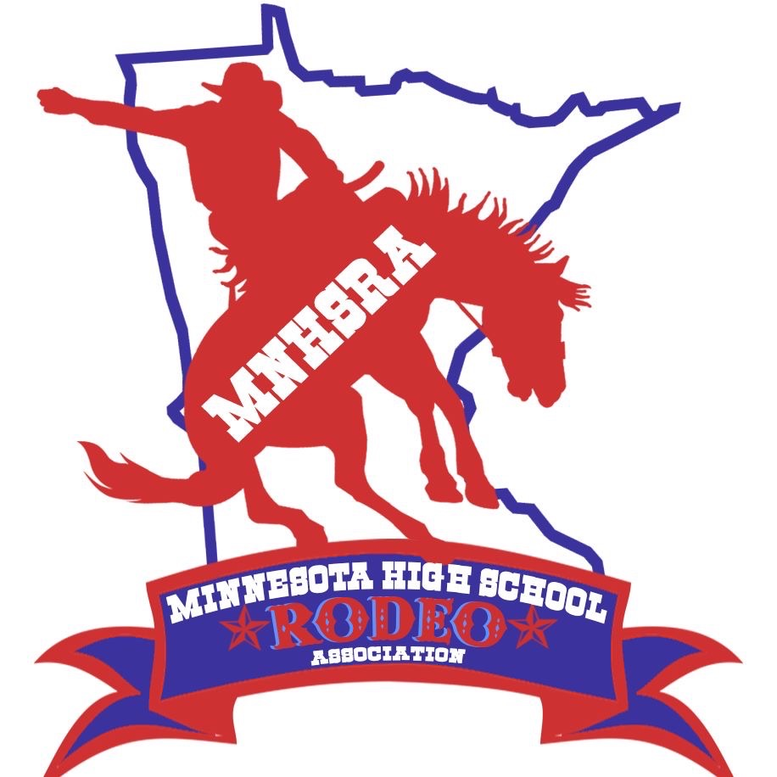 Cutting State Finals
May 14th & 15th
Steele County Fairgrounds
Owatonna, Minnesota 55060

Entries close Monday night 05/04/2026 at midnight.
Late Entries close Thursday night 05/07/2026 at midnight.
Draw Outs close Monday 05/11/2026 at midnight.

The HS Cutting is held with the Minnesota Cutting Horse Association.

State Finals at this time will be run on Thursday May 14 and Friday May 15
Not sure yet what day will have two runs

Contestants need to enter and compete in 3 rounds to be eligible for state finals.

