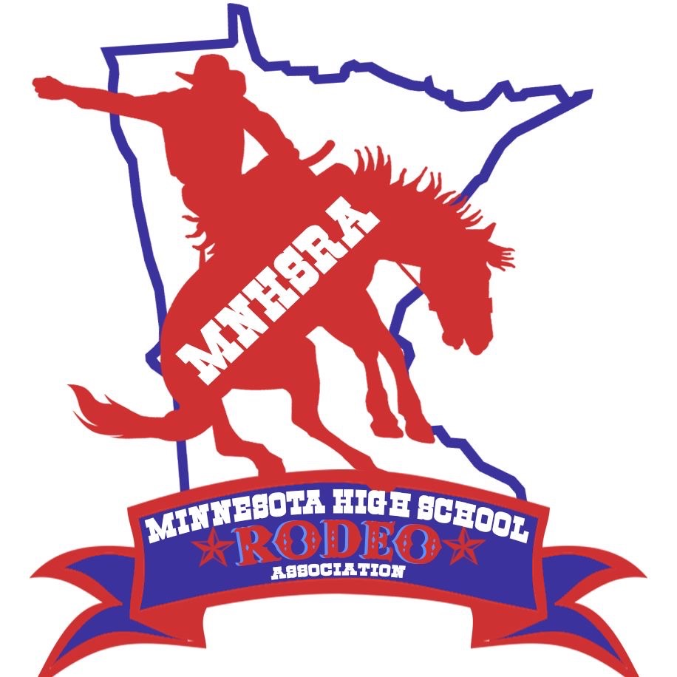Trap Shooting #5-8 Spring 2025
Friday 5/9/2025
Check in 6:30pm, Meeting 6:45pm, Start 7:00pm
Pine River Fish and Game Club
1537 24th AVE SW
Pine River, MN

Entries close Monday 4/28/25 at midnight.
Late Entries close Thursday 4/8/25 at midnight.
Draw Outs close Monday 5/5/25 at midnight.

Trap Shooting – 25 Shells per round
Contestants must provide own gun & ammunition
All Contestants MUST have hearing and eye protection
Back Numbers will be required.
Review dress code section NHSRA Shooting Sports Rulebook.

