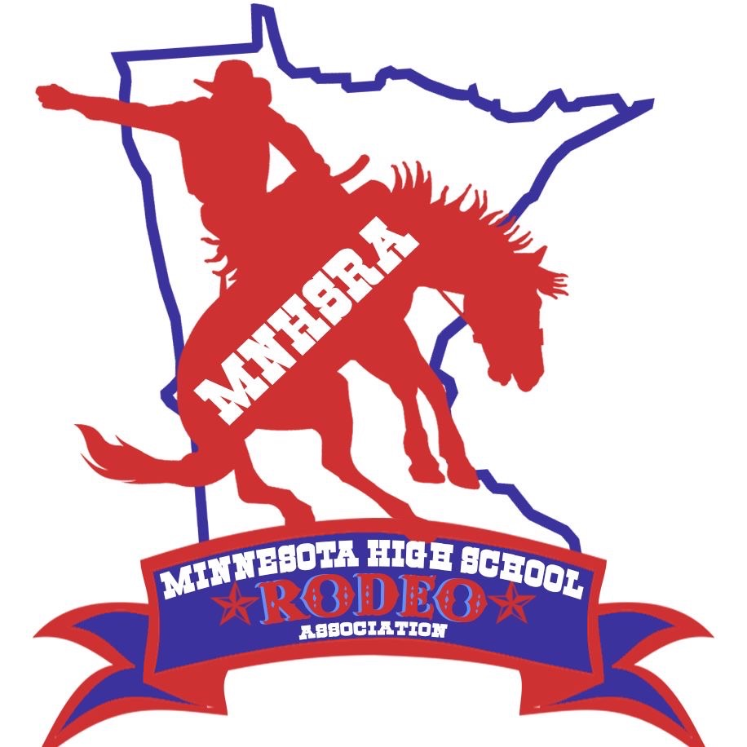Trap Shooting State Finals Spring 2025

Friday 5/16/2025

Check in 6:00pm, Meeting 6:15pm, Start 6:30pm

Bald Eagle Sportsman’s Association
6557 N 125th St
Hugo, MN 55038

Trap Shooting – 25 Shells per round
Contestants must provide own gun & ammunition
All Contestants MUST have hearing and eye protection
Back Numbers will be required.
Review dress code section NHSRA Shooting Sports Rulebook.

