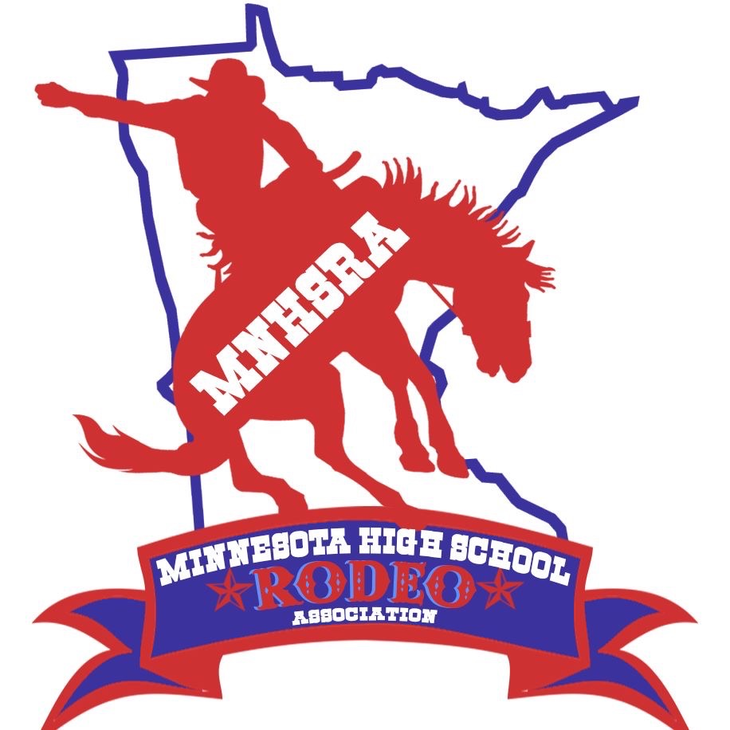Student Officers for 2025-2026
Queen: Pearl Overby
HS student president: Brea Richards
HS student vice president: Chloe Faus
HS student secretary: Mia Holmstrom
JH Princess: Claire Brown
JH student president: Broc Wagner
JH student vice president: Stetson Melby
JH student secretary: Ella Koch
Event Directors for 2025-2026
Saddle Bronc: Hunter Mancina
Bareback: Tristan Schwarz
Bulls:
Team Roping: Hadley Wagner
Breakaway: Mia Holmstrom
Goats: Riley Boerboom
Tie Down: Colt Richardson
Steer Wrestling: Lane Spencer
Barrels: Khloe VanVickle
Poles: Addison Sullivan
Girls Cutting: Ava Grove
Boys Cutting:
Reined Cow Horse: Isy Scheffel
Shooting: Lorn Harstad

