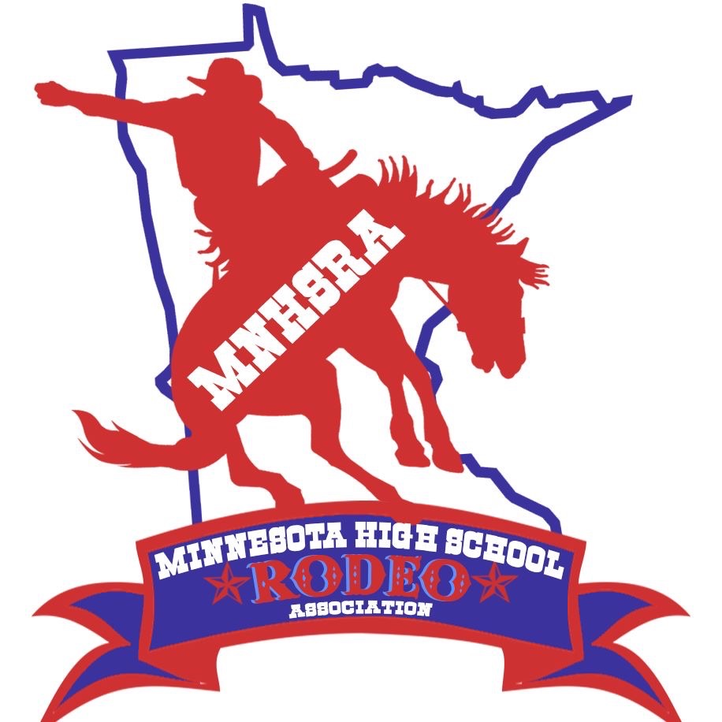 RCH # 7, 8, 9
March 21 & 22
Simons Arena
29100 Harry Ave
Cannon Falls, MN 55009

Entries close Monday night 03/09/2026 at midnight.
Late Entries close Thursday night 03/12/2026 at midnight.
Draw Outs close Monday 03/16/2026 at midnight.

The HS RCH is held with the North Central Reined Cow Horse Association.

#7,8,9 at this time will be run at Saturday and Sunday.
Not sure yet what day will have two runs.
~Need to enter online thru the MNHSRA website (like all the region rodeos) and we also ask that you go online to the website www.ncrcha.com to reserve your stall. (Stalls are required even if you haul in for the day)
~Patterns will be available at check in.
Contestants need to enter and compete in 3 rounds to be eligible for state finals.

