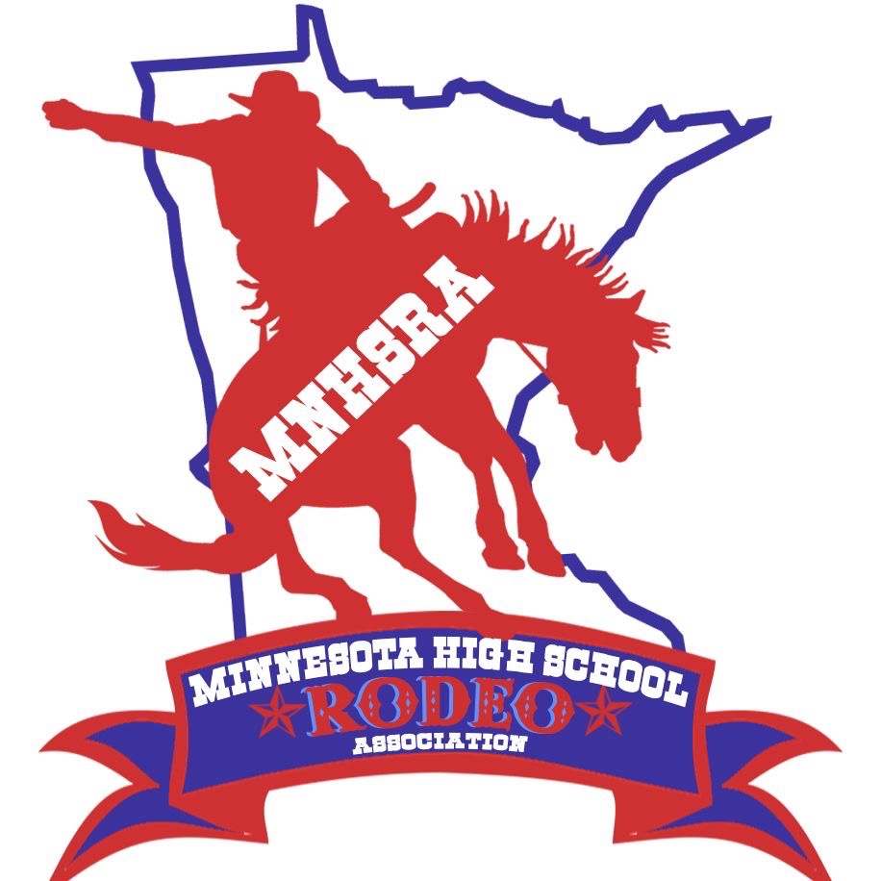Student Officers for 2026-2027
Queen: Megan Broich
HS student president: Ella Smith
HS student vice president: Kenzie Feia
HS student secretary: Riley Boerboom
JH Princess: Charli Tate
JH student president: Hayden Dilley
JH student vice president: Mylee Irvine
JH student secretary: Kenzie Fisher
Event Directors for 2026-2027
Saddle Bronc: Ruger Block
Bareback: Blaine Carroll
Bulls:
Team Roping: Hadley Wagner
Breakaway: Abby Wheeler
Goats: Maria Balsimo
Tie Down: Cora Schlosser
Steer Wrestling: Weston Feist
Barrels: Shyanne Purcell
Poles: Addison Sullivan
Girls Cutting:
Boys Cutting:
Reined Cow Horse: Isy Scheffel
Shooting:

